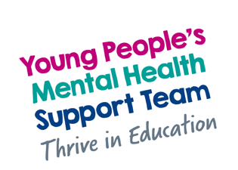



Webinars to support young people’s mental wellbeing.

  - Pennine Care’s Mental Health Support Team have produced a webinar on the important topic of supporting children and young people with sleep. This webinar will include the science behind sleep and some practical support tips for improving sleep hygiene. Education staff and parents/carers are very welcome to attend.

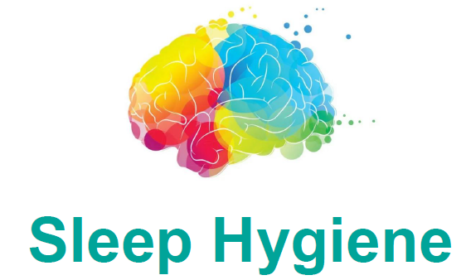

Friday 20th March 2026
3.30pm

Microsoft Teams meeting
Join: https://teams.microsoft.com/meet/34572986803368?p=QhCMFETYD7uqZkDBkJ
Meeting ID: 345 729 868 033 68
Passcode: fg2Lw9Xp

  - To access the webinar just click on the meeting links above. When joining you will be required to give your name, email address and the education setting your child attends in Oldham.

